Pulse Shaping

The channel simulation program offers two choices for pulse shaping: rectangular or raised cosine. The raised cosine pulses allow the user to select alpha. A few values are unavailable due to asymptotes in the raised cosine function. The formula used to generate an individual pulse is from Rappaport, p.287, and is shown below.

The raisedCosine.__init__ method converts the four input variables (alpha, period, samples, and numperiods) to object attributes. The raisedCosine.raisedCos method generates an array of numperiods raised cosine pulses. The raisedCosine.run method simply calls the raisedCosine.raisedCos method. The pulse array is used later in the symbol dictionary module, where it is multiplied by a modulated binary string. Examples of the raised cosine output are shown in the three figures below. The first is an example of raised cosine pulses with varying values of alpha. The second is an example of pulse shaped QPSK. The third is a comparison of the spectrum of a raised cosine pulse with the spectrum of a rectangular pulse.

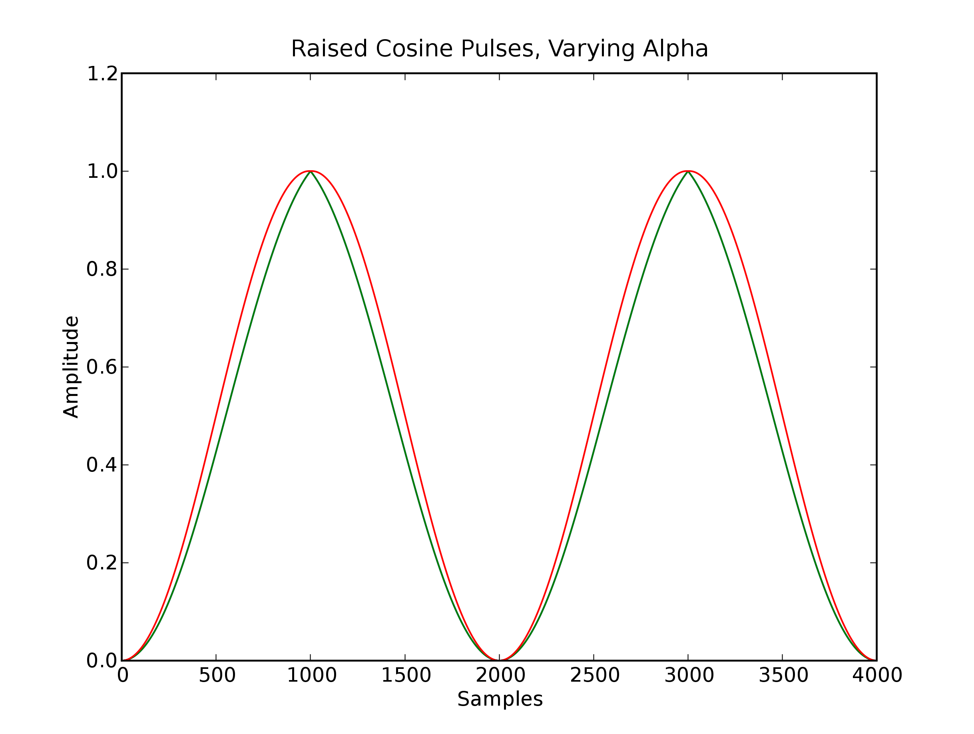Fig 1: Raised cosine pulses with two different values for alpha.

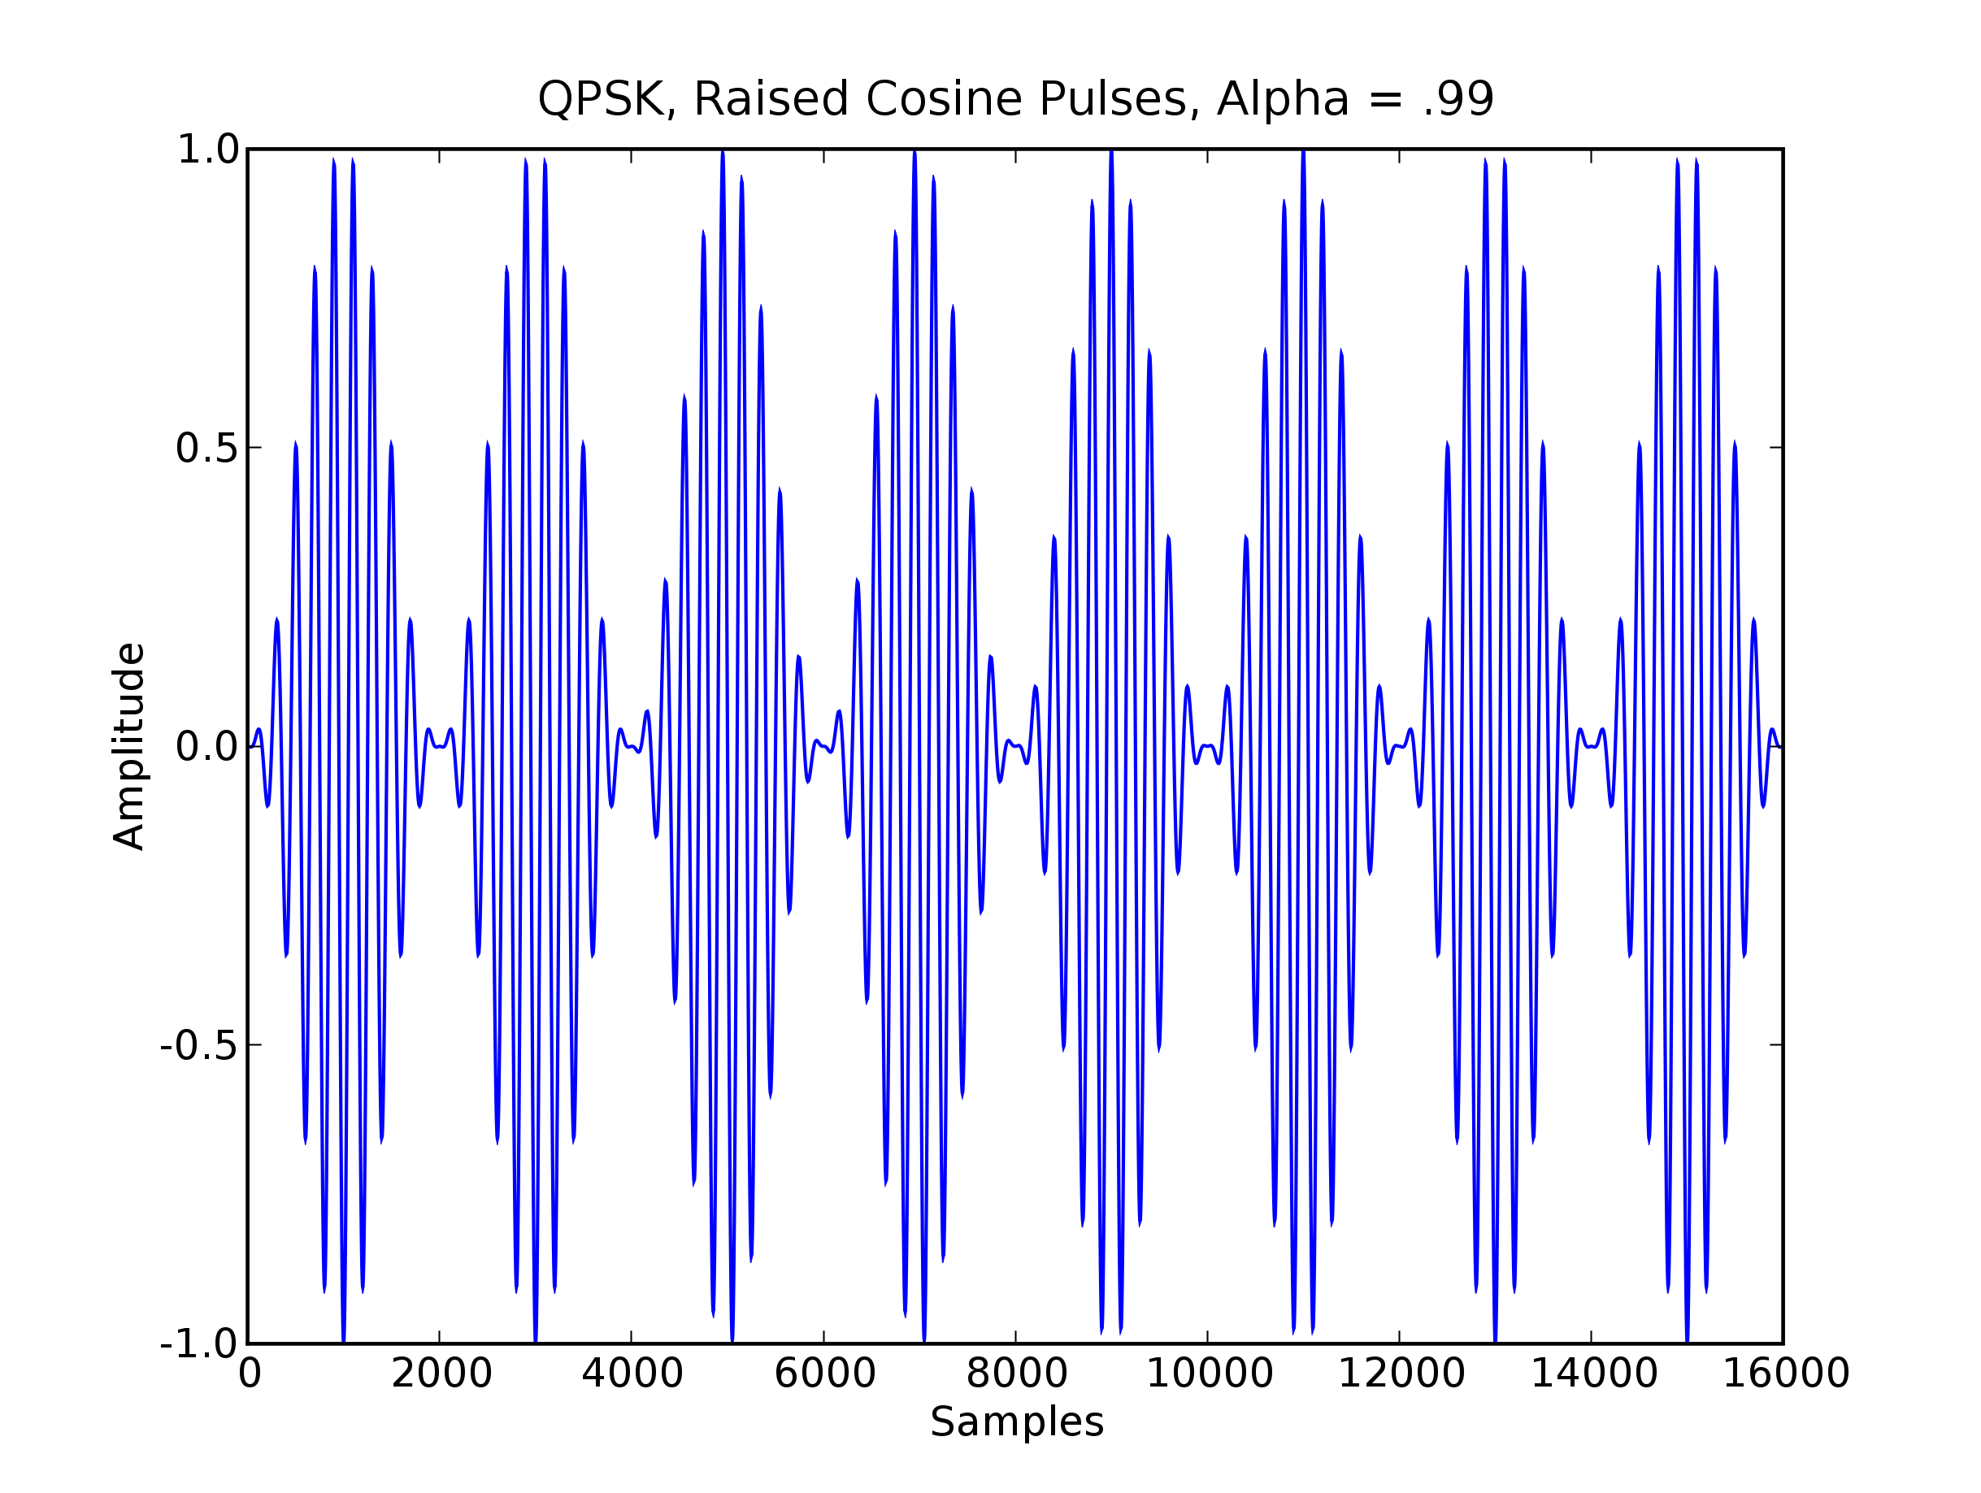Fig 2: Raised cosine pulse shaped QPSK.
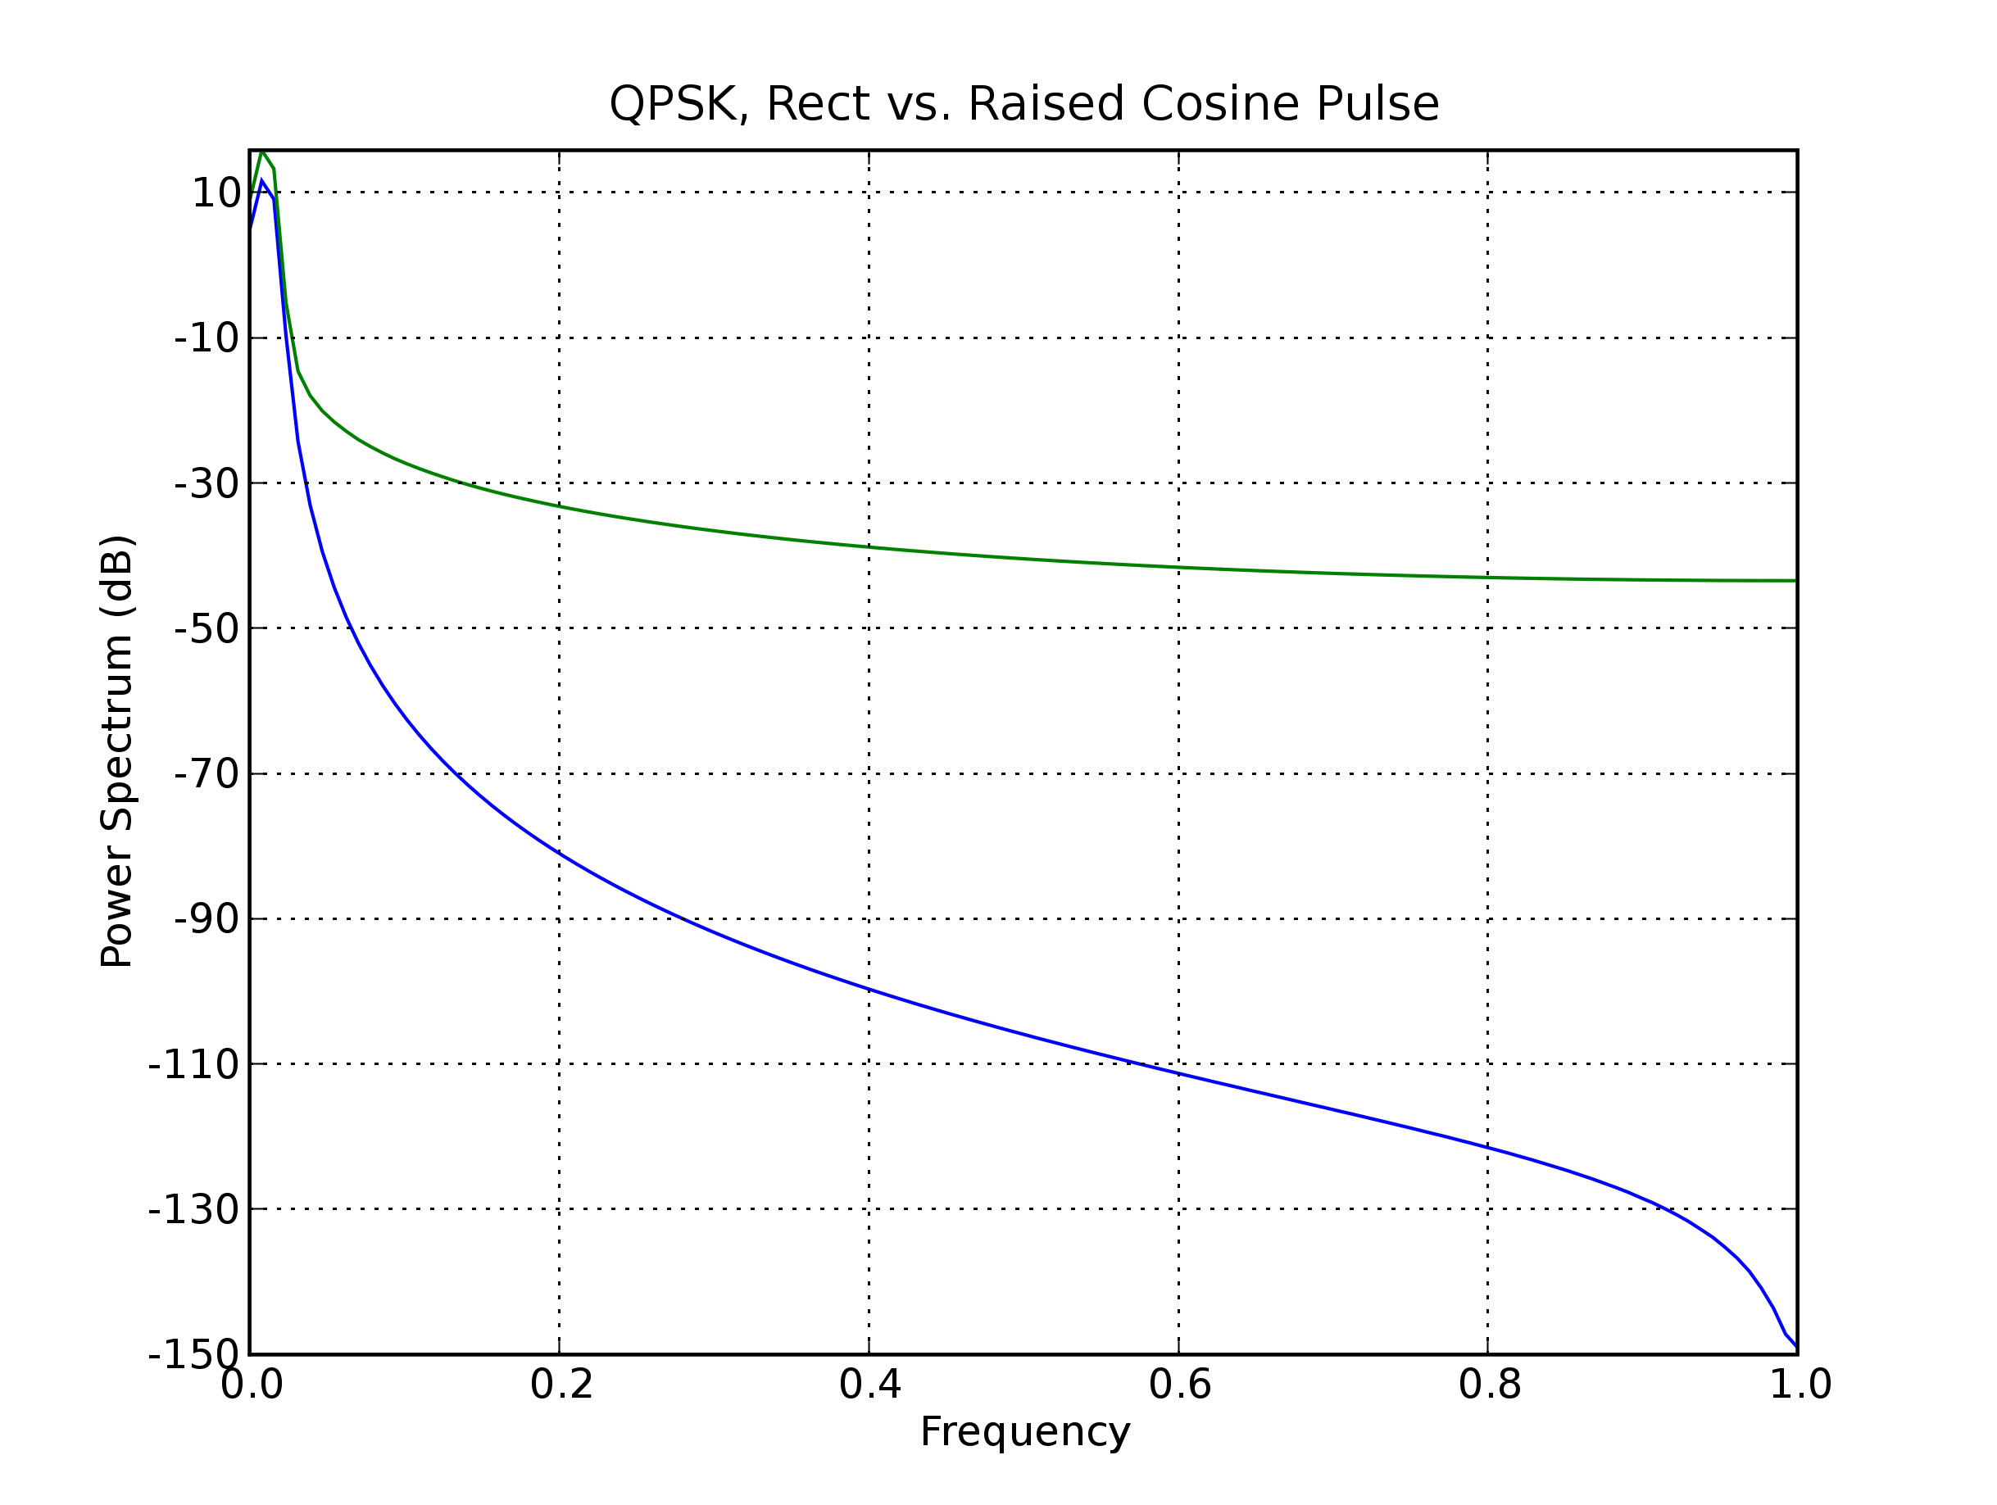Fig 3: Spectral comparison of raised cosine and rectangular pulses.
Usage:

from pulses import *
rcinstance = raisedCosine(alpha, period, samples, numperiods)
outputarray = rcinstance.run()

or

from pulses import *
rectinstance = rect(alpha, period, samples, numperiods)
outputarray = rectinstance.run()

alpha: A factor in the raised cosine class that determines rolloff. Unused in rect.
symperiod: The duration of one symbol period
samples: The number of samples per period in the array returned
numperiods: The number of symbol periods in the array returned
outputarray: An outgoing pulse train

